Low Wood Hall
Nether Wasdale

1 course – £14.95
2 courses – £18.95
3 courses - £21.95

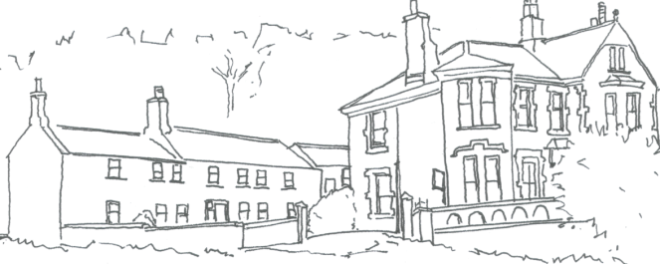

Starters
Leek & Potato Soup
Roll and butter

Greek Salad
Tomatoes, peppers, feta cheese

Creamy Garlic Mushrooms
Crusty bread roll

Chicken, Prune & Leek Terrine
With picalilly

Main Courses

Panfried Chicken Breast
Served with wild mushroom sauce and crushed new potatoes

Cumberland Sausage
Mash, gravy and red onion marmalade

Grilled Cod
Crushed new potatoes and white wine & parsley sauce

Braised Ox Cheek
Mash and red wine jus

Roasted Vegetable Tagine
Served with cous cous

Desserts

See board for selection of desserts

Coffees & teas from £2.00

